Day 7 - 04th June 2025

Java
Java basics | Data Types, Variables, Operators, Control Statements, Loops, Arrays, Classes, Objects,

Task 001:
Create a code to display
“Hello guys!!!! “
“We are learning Java”

Using a single output statement…
Output:
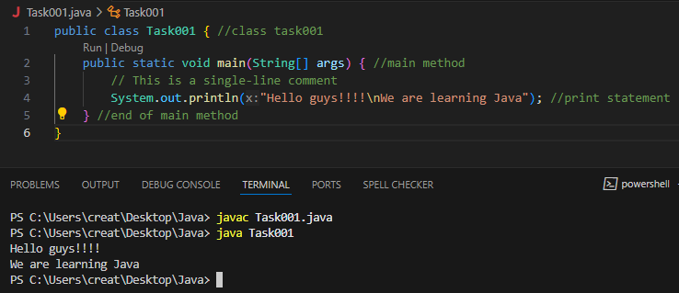

Task 002:

Write a Program in Java to Add two Numbers.
Input: 2 3
Output: 5
Output:
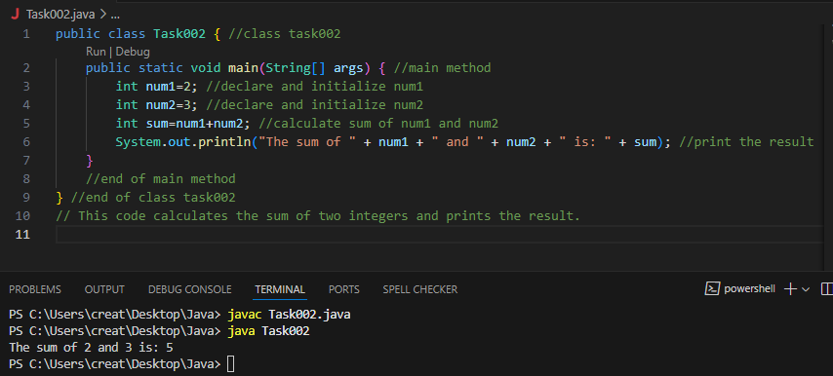
Task 003:

Write a Program to Swap Two Numbers
Input: a=2 b=5
Output: a=5 b=2
Output:
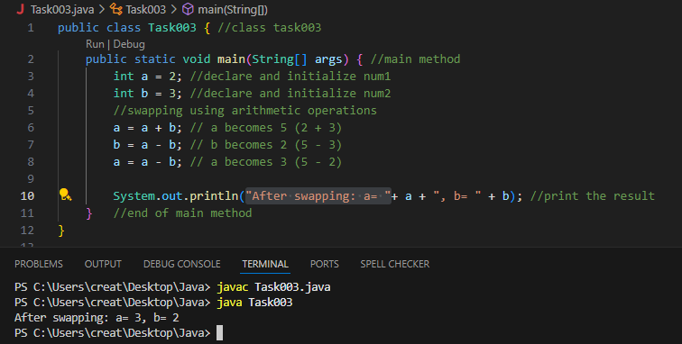

Task 004:
Create a code in which you have 4 methods add, subtract, multiply and divide (return type int) with a main method .to all all the other methods
Output:
Main started
Sum of 2 numbers is …..
Diff of 2 numbers is —-
Product of 2 numbers ….
Division of 2 numbers is ….
Main ended
Output:
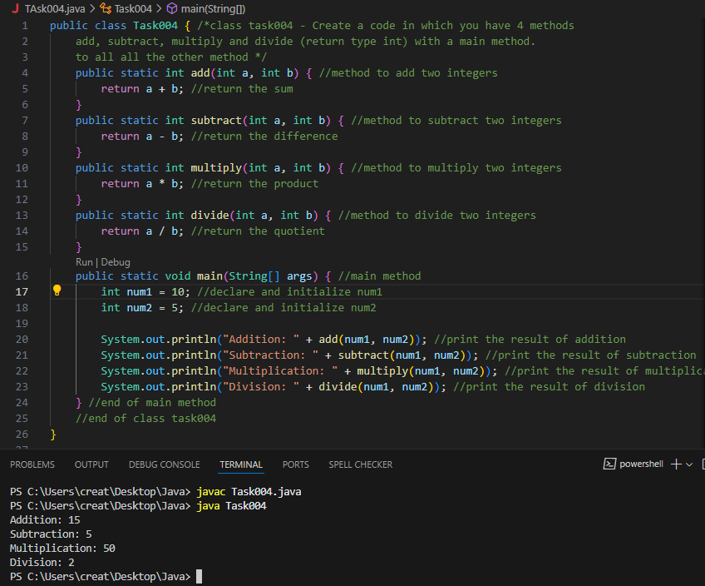

Task 005:
Write a program to check if a is greater or b.. Use ternary op
Output:
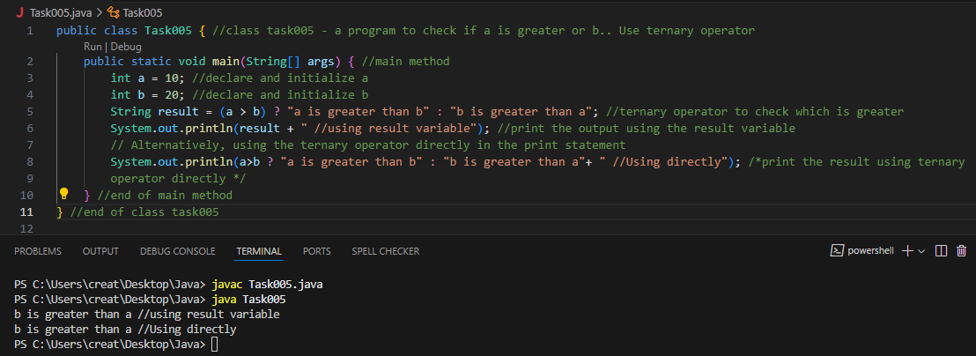
Task 006:

Write a program to take input from the user and display it to the user
Input:
Id : Prasuanmba
Pwd: 123456789
Output:
Hi ,
Your login id is Prasuanmba
And your pwd is *********

HInt :
For scanner … import java.util.scanner;
Scanner sc = new Scanner(System.in);
Id = sc.nexLine();
Output:
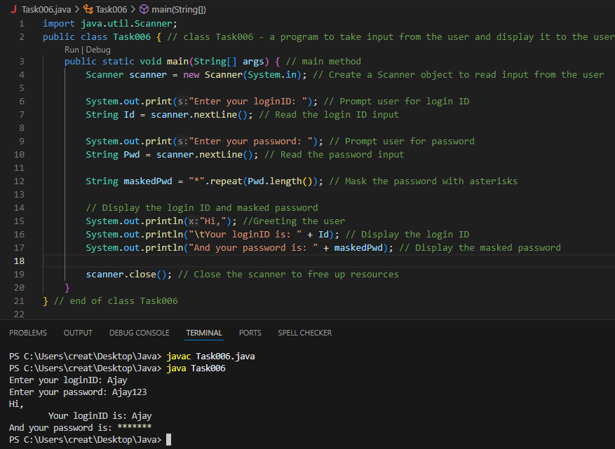
Task 007:

Write a program to create a class named Customer
Call the customer class in Task007 class using an object
Hint

In the main method
Class Customer{
Void accept(){

sysout(“accept customer called”);
}
Void display(){
sysout(“display customer called”);
}
}
Public class Test007{
psvm(String[] argos){
Customer cobj = new Customer();
cobj.accept();
cobj.display();
}
}
Output:
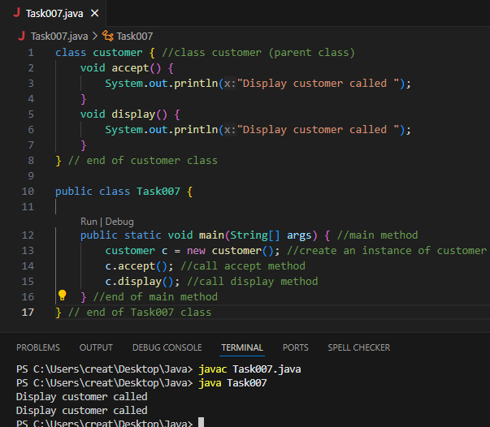
Task 008:

Wap to check the greater of 2 numbers

Hint:
Use if else

If ( num1 > num2){
sout(“num1 is greater”);
}
Else {
sout(“num2 is greater”);
}
Output:
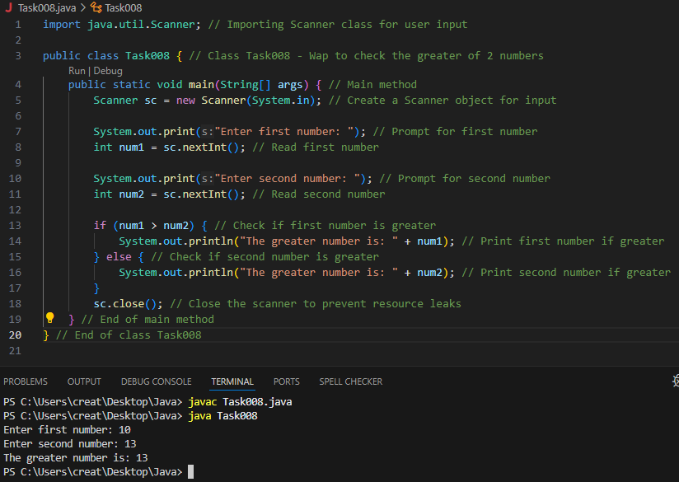

Task 009
Wap to check greater of 3 numbers

Use elseif
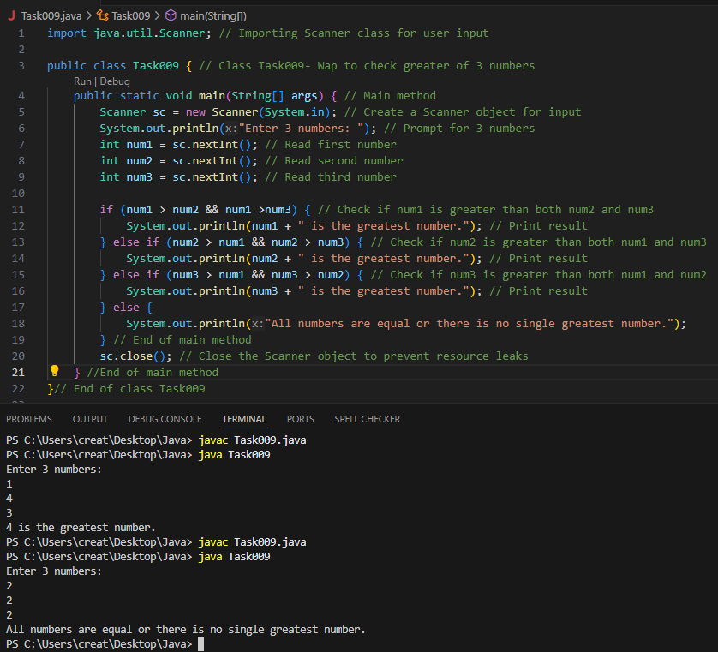

Task 010:

Wap to check if check week days

1 ===> sunday
2 ===> monday
So on

8 and above ===> invalid input

Hint : use Switch case
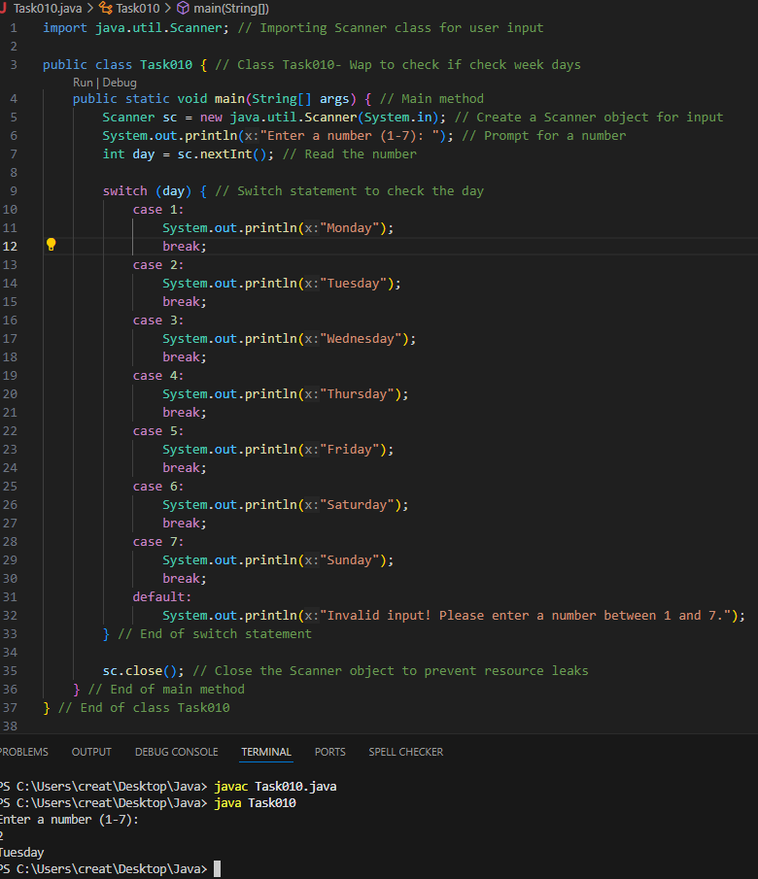

Task 011:

Wap to check loginid and password validation
Hint use while loop

Scanner sc = new Scanner(System.in);

String loginid = “Prasunamba”
String pwd = “12345867”
Int Count = 0;

While (loginid == “Prasunamba” && pwd == “12345867”){
sout(“ you have logged in for ”+ count++ +” times”);
sout(“enter ur login id and password”);
loginid = sc.NextLine();
pwd = sc.NextLine();
}
Output:
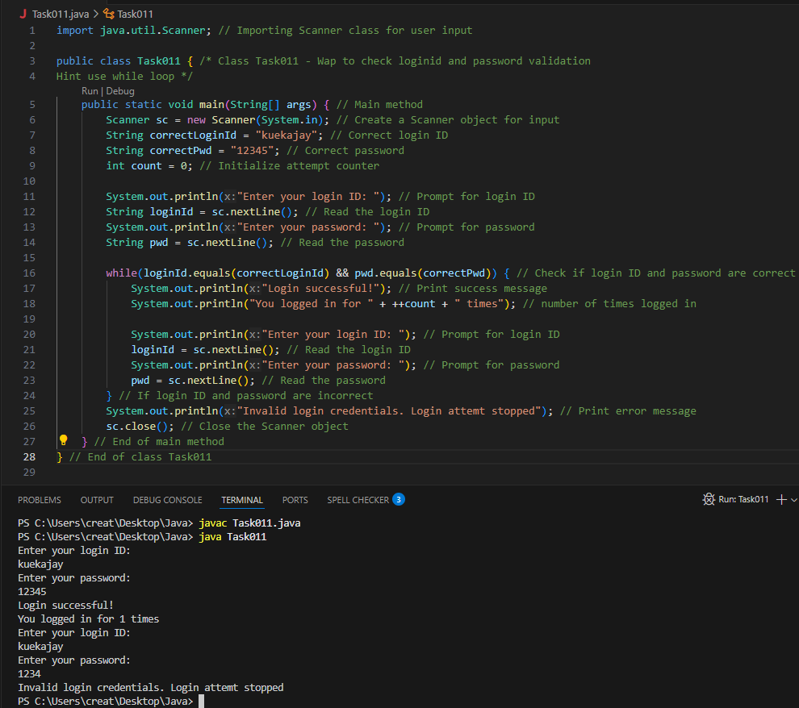

Task 012:

Same as above qn but use do while loop

Scanner sc = new Scanner(System.in);

String loginid = “Prasunamba”
String pwd = “12345867”
Int Count = 0;

do{
sout(“ you have logged in for ”+ count++ +” times”);
sout(“enter ur login id and password”);
loginid = sc.NextLine();
pwd = sc.NextLine();
}While (loginid == “Prasunamba” && pwd == “12345867”);

sc.close();

Output:
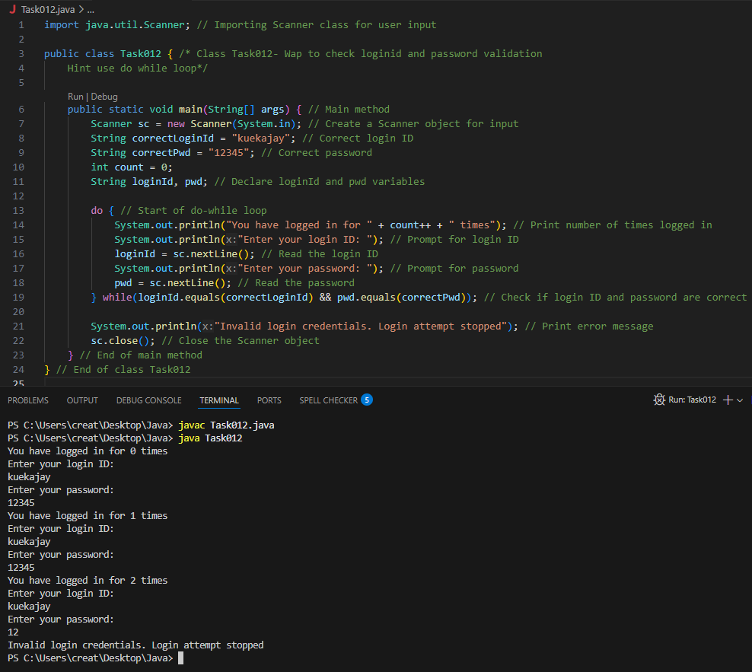

Task 013:
Wap to display numbers from 10 to 1 .. skip 7 and 5.

for(int i= 10; i >0; i–){
If ( i == 5 || i == 7){
Continue;
sout(i);
}
Output:
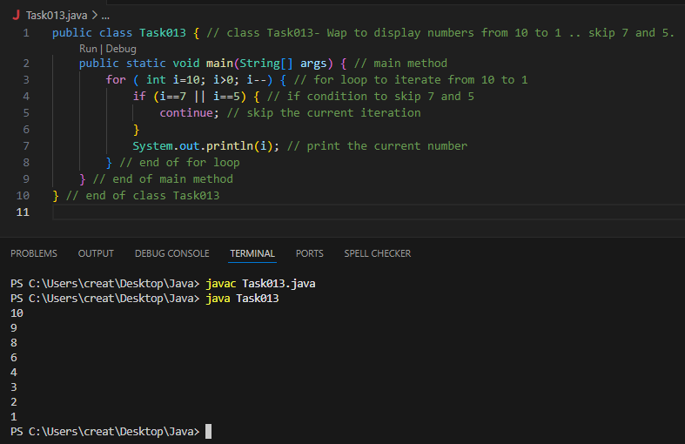

Task 014:

Arrays:

Try the below code and display the output…
Now play with it try to access 5th index and see the output…and try to access -1 index and see the output..

package Arrays;

public class Demo01 {

public static void main(String[] args) {
// TODO Auto-generated method stub
char[] arr = {'a','e','i','o','u'};
System.out.println(arr);
String[] names = {"Meena", "Tina", "Veena", "heena"};
System.out.println(names[0]);
names[1]= "Reena";
System.out.println(names[1]);
System.out.println(names.length);
System.out.println(names[4]);
//Exception in thread "main" java.lang.ArrayIndexOutOfBoundsException

}

}
Output:
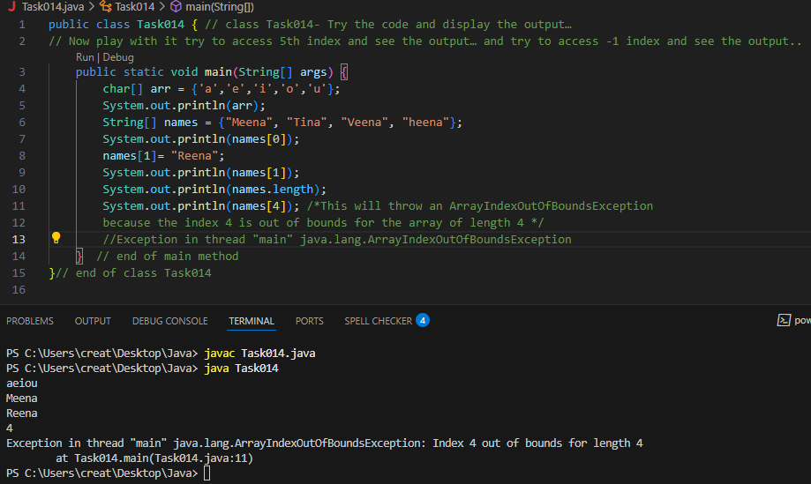

access 5th index
Output:
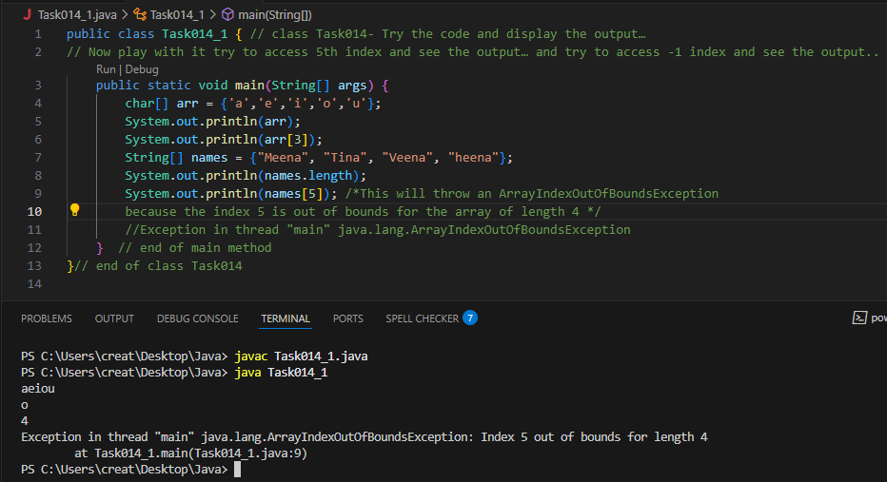

Access -1 index
Output:
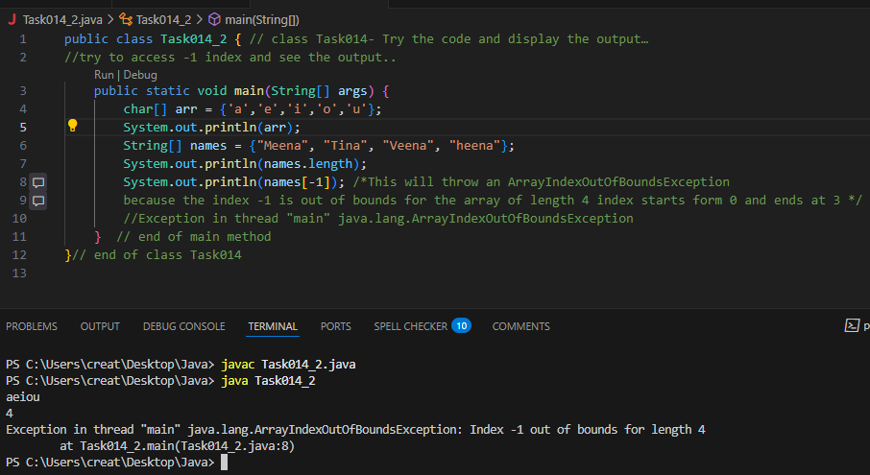

Strings:

Task 015:

package StringHandling;

public class Demo01 {

public static void main(String[] args) {
// TODO Auto-generated method stub
String str1 = "Java Strings "; // string Literal
String str2 = new String(str1); // obj of the string - new keyword
String str3 = new String("are easy to learn ");
char ch[] = {'S', 't', 'r' ,'i', 'n', 'g'};
String str4 = new String(ch);
System.out.println(str1 + "\n" + str2 + "\n" +str3 + "\n" +str4);
}
}

Output:
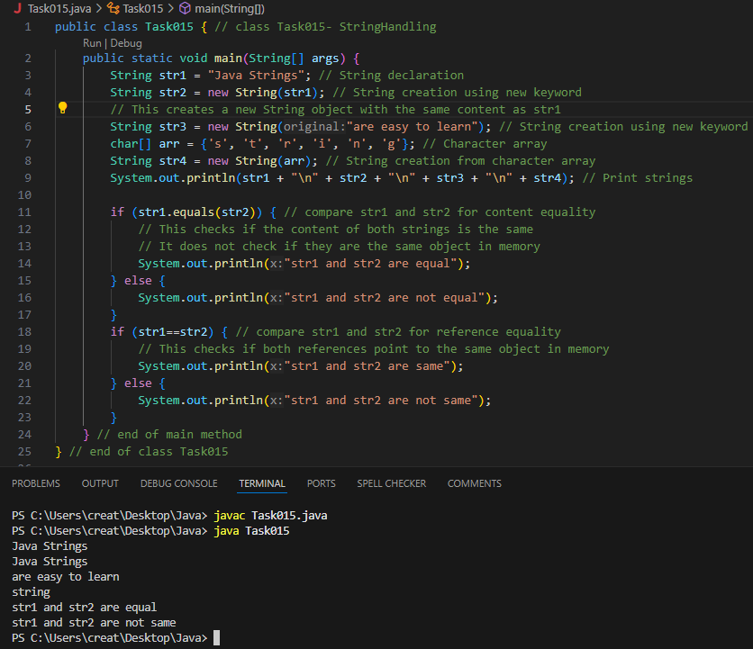

Task 016:

Enums or Enumerations

What is the output of the below code snippet

package Enumerations;
enum color{
red, blue, green, yellow
}
public class Demo01 {

public static void main(String[] args) {
color c1 = color.yellow;
System.out.println(c1);
}
}
Output:
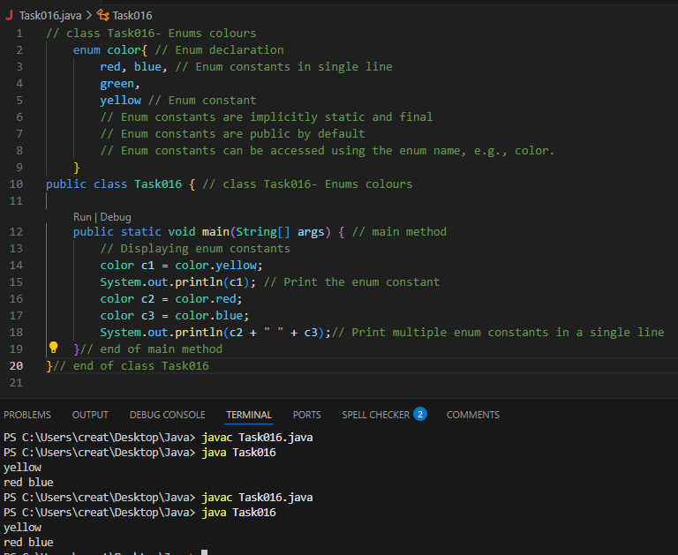

Task 017:
Getter and setter
Create a program name Person.java

public class Person {
private String name;

// Getter
public String getName() {
return name;
}

// Setter
public void setName(String newName) {
this.name = newName;
}
}
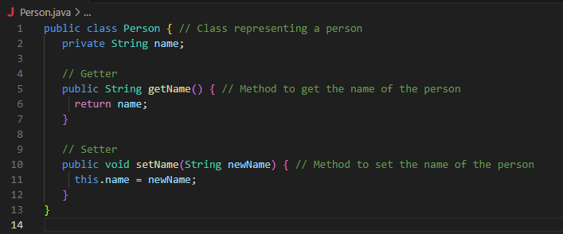
Create another program named Task017.java

public class Task017{
public static void main(String[] args) {
Person myObj = new Person();
myObj.name = "John";
System.out.println(myObj.name);
}
}

Output:
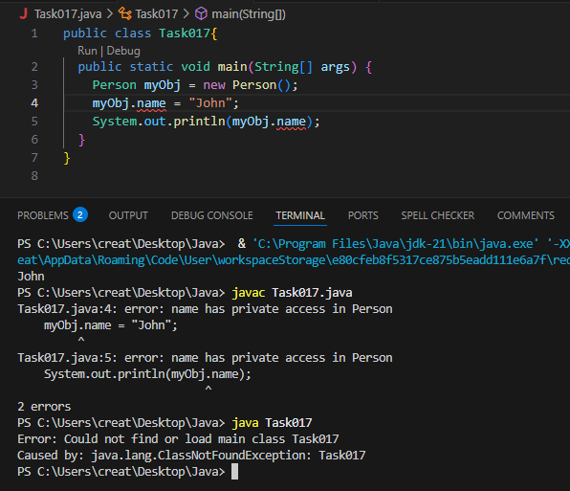

—----------------------------------what is the reason for the error —---------------explain
Error because the method calls name("John") and name() do not exist in the Person class. Java does not automatically create setter and getter methods for attributes unless explicitly defined

Task 018:
Now create one more program named Task018.java
public class Main {
public static void main(String[] args) {
Person myObj = new Person();
myObj.setName("John");
System.out.println(myObj.getName());
}
}
Output:
